**13. Reactjs-HOL**

**Step 1:** Create a react app named **bloggerapp**

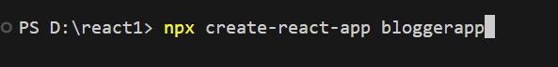

**Step 2:** Create three components as given below

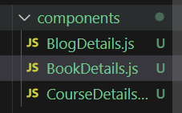

**Step 3:** Create three files for data import

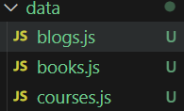

**Step 4:** Write the following code in all of the data files

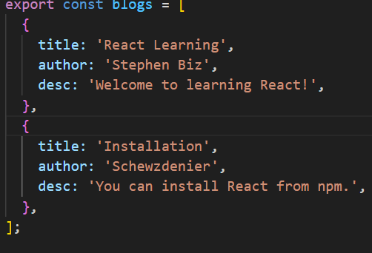

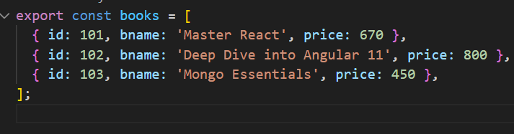

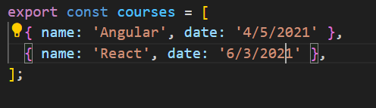

**Step 5:** Write the following code in all of the component folder files

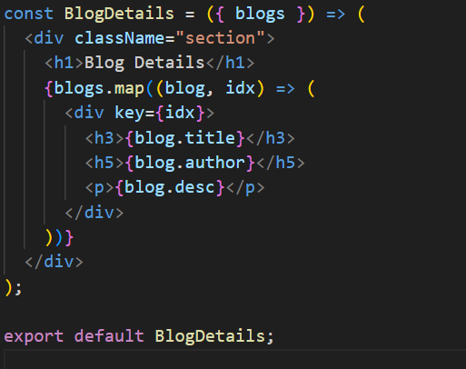

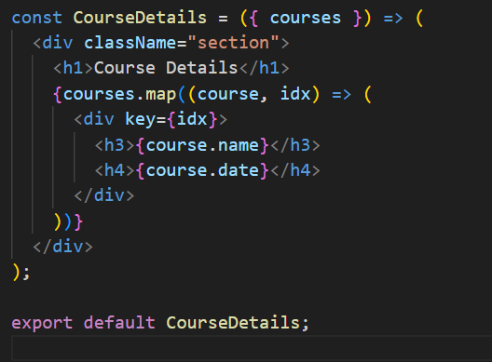

First way of rendering   
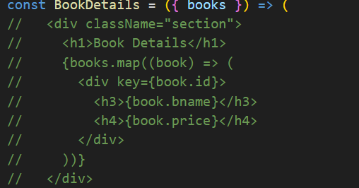

Second way of rendering   
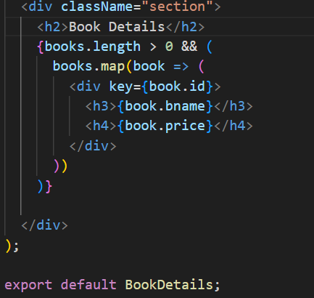

**Note:** These details can also be rendered by if else conditions and switch cases.

**Step 6:** Write the following code in App.js file

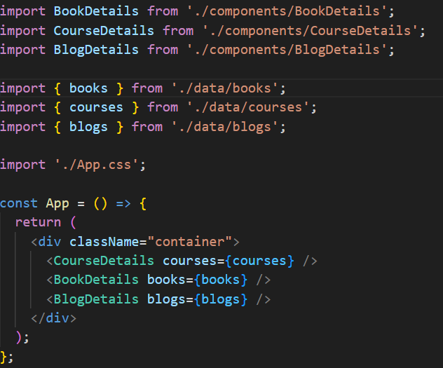

**Step 7:** Write the following code for styling purposes in App.css file

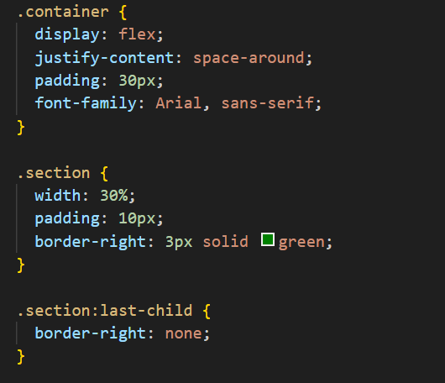

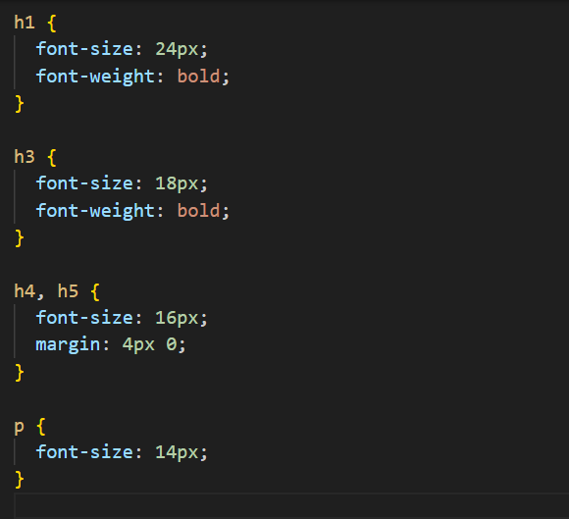

**Output:** The Output should look like this.

